Assingment -4

Name- Somil UID-22BCS15065 Section- 603-A

[**1763. Longest Nice Substring**](https://leetcode.com/problems/longest-nice-substring/) Code:

|  |
| --- |
| class Solution  { public:  string longestNiceSubstring(string s) { if (s.size() < 2) return ""; unordered_set<char> st(begin(s), end(s)); for (int i = 0; i < s.size(); i++) { if (st.find((char) toupper(s[i])) == end(st) || st.find((char) tolower(s[i])) == end(st)) { string s1 = longestNiceSubstring(s.substr(0, i)); string s2 = longestNiceSubstring(s.substr(i + 1)); return s1.size() >= s2.size() ? s1 : s2;  } }  return s;  }  }; |

Output:

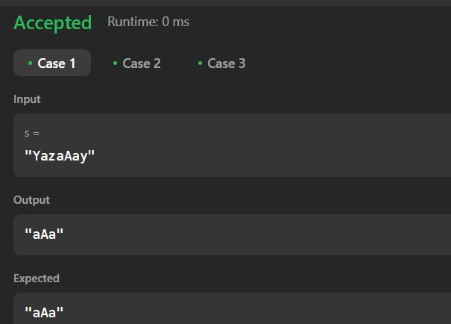

1. [**Reverse Bits**](https://leetcode.com/problems/reverse-bits/) Code:

|  |
| --- |
| class Solution { public:  uint32_t reverseBits(uint32_t n) { uint32_t result = 0; for (int i = 0; i < 32; i++) { int bit = n & 1; result = (result << 1) | bit; n = n >> 1;  } return result;  }  }; |

Output:

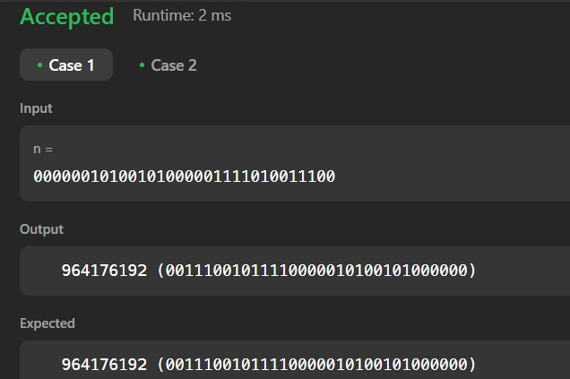

1. [**Number of 1 Bits**](https://leetcode.com/problems/number-of-1-bits/) Code:

|  |
| --- |
| class Solution { public:  int hammingWeight(int n) { return __builtin_popcount(n);  }  }; |

OUTPUT:

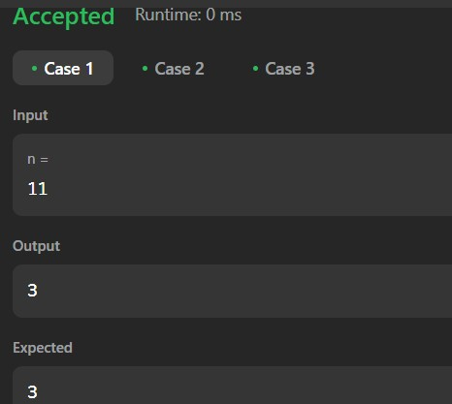

[**53. Maximum Subarray**](https://leetcode.com/problems/maximum-subarray/) Code:

|  |
| --- |
| class Solution { public:  int maxSubArray(vector<int>& nums) { int n = size(nums), ans = INT_MIN; for(int i = 0; i < n; i++) for(int j = i, curSum = 0; j < n ; j++) curSum += nums[j], ans = max(ans, curSum); return ans;  }  }; |

OUTPUT:

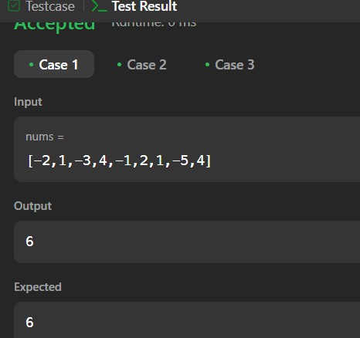

[**240. Search a 2D Matrix II**](https://leetcode.com/problems/search-a-2d-matrix-ii/)  Code:

|  |
| --- |
| class Solution { public:  bool searchMatrix(vector<vector<int>>& matrix, int target) { int row = matrix.size(); int col = matrix[0].size();  //top-right conrer int i = 0; int j = col-1;    while(i <= row-1 && j >= 0){  if(matrix[i][j] == target) return true; else if(matrix[i][j] < target) i++; else j--;  }  return false;  }  }; |

Output:

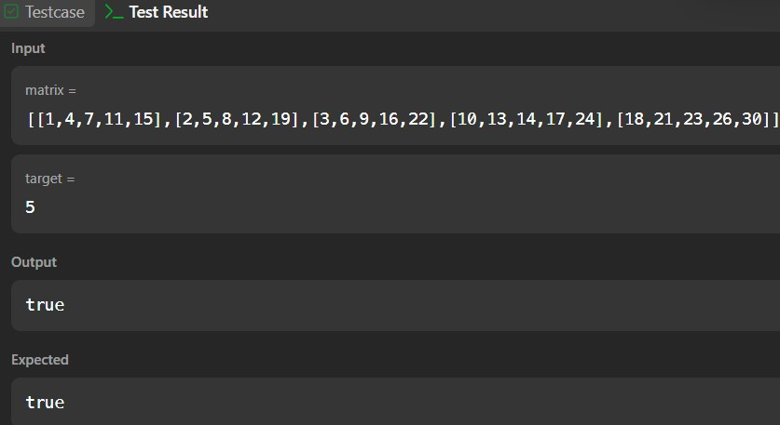

[**372. Super Pow**](https://leetcode.com/problems/super-pow/) Code:

|  |
| --- |
| class Solution { public: int find(int a,int b)  { a%=1337; int res=1;  for(int i=0;i<b;i++)  { res*=a; res%=1337;  }  return res;  } int superPow(int a, vector<int>& b) { int res=1,x,f; for(int i=0;i<b.size();i++)  {  x=find(a,b[i]); x*=res; x%=1337; f=x; x=find(x,10); res=x;  }  return f;  }  }; |

Output: 